

Job Title: Electrical Contracts Manager | Team: Trent Valley Electrical Services
Service: Commercial | Responsible to: General Manager

Job Summary
The Electrical Contracts Manager will take full commercial and operational responsibility for the electrical division, from initial enquiry and pricing through to successful delivery and final account.

The role is responsible for securing new work, preparing competitive and profitable quotations, mobilising contracts and ensuring projects are delivered safely, compliantly, on time and within agreed margins.

This is a key leadership position within the business, supporting the continued growth of electrical services including commercial works, testing and inspection programmes, solar PV, EV charging and battery storage.
The successful candidate will combine strong technical knowledge with commercial awareness and the ability to lead and develop a team.

Main Responsibilities
Commercial & Business Development
- Identify and actively pursue new commercial opportunities within electrical and renewables markets
- Undertake site surveys and prepare detailed, accurate and commercially sound quotations
- Build and maintain strong client relationships to secure repeat and long-term business
- Support framework registrations and networking activity to grow market presence
- Contribute to the strategic growth of the electrical and renewables division

Contract & Financial Management
- Take ownership of contract budgets, cost control and gross margin performance
- Ensure projects are delivered within agreed budgets and timescales
- Manage variations, valuations, applications for payment and final accounts
- Provide accurate monthly financial and operational reporting to the General Manager
- Monitor and manage supplier costs and procurement

Operational Delivery
- Mobilise new contracts and lead client meetings where required
- Manage day-to-day delivery of electrical works including repairs, EICRs, testing and inspection, solar PV, EV chargers and battery storage systems
- Resolve operational issues efficiently to protect programme and margin
- Ensure all certification and compliance documentation is completed accurately and issued within required timescales
- Define and manage site-specific RAMS and oversee Health & Safety compliance

Leadership & Team Management
- Line manage engineers and subcontractors across multiple projects
- Lead inductions, probation reviews, performance reviews and ongoing development
- Plan and coordinate labour resources effectively
- Support recruitment and growth of the electrical team
- Promote a positive, accountable and safety-focused working culture

Skills, Competence, Experience Required
- Proven experience managing electrical contracts from enquiry to completion
- Demonstrable experience pricing and securing electrical works
- Strong commercial awareness with understanding of margin, cost control and financial performance
- Practical industry experience in electrical installations, testing and inspection
- Experience in renewables (solar PV, EV charging, battery storage) desirable
- Recognised electrical qualifications (NVQ Level 3 Electrical Installation or equivalent)
- SSSTS or SMSTS desirable
- Good working knowledge of MS Office and job management/quoting software
- Strong communication and client management skills
- Organised, proactive and capable of managing multiple live projects

Health and Safety
- Ensure all works are delivered in full compliance with current electrical and Health & Safety regulations
- Promote a strong safety culture across all projects
- Identify and mitigate risks across operational and commercial activities
- Lone work may be a requirement for this role on occasions

Environment and Sustainability
- Support the company’s environmental and sustainability objectives
- Promote energy-efficient and renewable solutions where appropriate

Equality & Diversity
- Promote equality, diversity and inclusion across all stakeholders
- Ensure services are delivered with fairness, professionalism and respect

Position in Organisation
How many colleagues is the role responsible for? 8
Is the responsibility shared with another post? Yes – General Manager

Organisation Chart

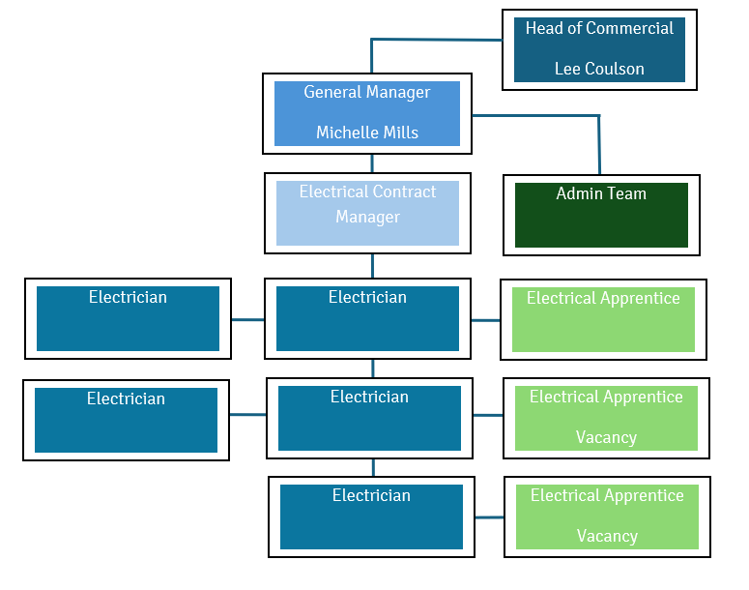

Notice Period
- 3 months




